Nama : Adi Saepul Anwar
NPM : 43A87006200129
Kelas : S1/TI/A/M
Matkul : Jarkom 2

Topologi
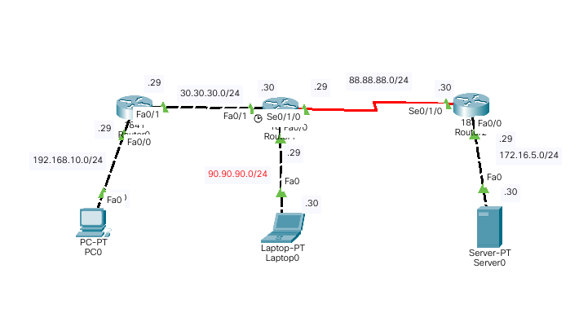

#Konfigurasi Router 0
Router>ena
Router#conf t
Router(config)#interface fa0/0
Router(config-if)#ip address 192.168.10.29 255.255.255.0
Router(config-if)#no sh
Router(config-if)#exit

Router(config)#interface fa0/1
Router(config-if)#ip address 30.30.30.29 255.255.255.0
Router(config-if)#no sh
Router(config-if)#exit

#Konfigurasi Ip Route
Router(config)#ip route 90.90.90.0 255.255.255.0 30.30.30.30
Router(config)#ip route 88.88.88.0 255.255.255.0 30.30.30.30
Router(config)#ip route 172.16.5.0 255.255.255.0 30.30.30.30

#Konfigurasi Router 1
Router>ena
Router#conf t
Router(config)#interface fa0/1
Router(config-if)#ip address 30.30.30.30 255.255.255.0
Router(config-if)#no sh
Router(config-if)#exit

Router(config)#interface fa0/0
Router(config-if)#ip address 90.90.90.29 255.255.255.0
Router(config-if)#no sh
Router(config-if)#exit

Router(config)#interface se0/1/0
Router(config-if)#ip address 88.88.88.29 255.255.255.0
Router(config-if)#no sh
Router(config-if)#exit

#Konfigurasi Ip Route
Router(config)#ip route 192.168.10.0 255.255.255.0 30.30.30.29
Router(config)#ip route 172.16.5.0 255.255.255.0 88.88.88.30

#Konfigurasi Router 2
Router>ena
Router#conf t
Router(config)#interface fa0/0
Router(config-if)#ip address 172.16.5.29 255.255.255.0
Router(config-if)#no sh
Router(config-if)#exit

Router(config)#interface se0/1/0
Router(config-if)#ip address 88.88.88.30 255.255.255.0
Router(config-if)#no sh
Router(config-if)#exit

#Konfigurasi Ip Route
Router(config)#ip route 90.90.90.0 255.255.255.0 88.88.88.29
Router(config)#ip route 30.30.30.0 255.255.255.0 30.30.30.29
Router(config)#ip route 192.168.10.0 255.255.255.0 30.30.30.29

